Practical - 1
Practical Title: Project Initiation, Requirement Analysis, Sitemap, Wireframe, and GitHub Setup

Problem Definition: Initiate the semester-long Student Hub portal by identifying the problem scope, user roles, key modules, navigation flow, and minimum 10 pages. Create a sitemap, low-fidelity wireframe, project folder structure, README file, and GitHub repository.

Theory

What is URL and parts of URL?
Answer: A URL (Uniform Resource Locator) is the address used to locate a particular resource on the Internet. It tells the web browser where a webpage or other online resource is available.
The main parts of a URL are:
Scheme or Protocol
- Scheme/Protocol - defines the type of Internet service (most common is http or https)
- Prefix - defines a domain prefix (default for http is www)
- Domain name - defines the Internet domain name (like w3schools.com)
- Port address- defines the port number at the host (default for http is 80)
- Path - defines a path at the server (If omitted: the root directory of the site)
- Filename - defines the name of a document or resource

Reference Link:
https://www.w3schools.com/html/html_urlencode.asp

How does HTML file process in web browser?
Answer: When an HTML file is opened in a web browser, the browser reads the HTML document and uses the HTML elements to understand how the webpage should be displayed. HTML provides the structure of the webpage using elements such as <html>, <head>, <title>, and <body>.
The browser does not display the HTML tags themselves. Instead, it uses these tags to decide how the content should appear on the screen. The content written inside the <body> section is displayed as the visible part of the webpage, while the <title> is displayed in the browser tab.
When the webpage is loaded, the browser also creates a Document Object Model (DOM), which represents the HTML page as a tree of objects. This allows the webpage and its elements to be accessed and modified using JavaScript.

Reference Link:
https://www.w3schools.com/html/html_intro.asp
https://www.w3schools.com/whatis/whatis_htmldom.asp

3. How will page navigation flow managed among all HTML pages?
Answer: Page navigation in the StudentHub portal will be managed using HTML links with the <a> (anchor) tag. The href attribute is used to specify the destination of the link. When the user clicks a link, the browser opens the webpage specified in the href attribute.
For example, the StudentHub navigation bar can be created as:
<nav>
<a href="index.html">Home</a>
<a href="courses.html">Courses</a>
<a href="assignments.html">Assignments</a>
<a href="attendance.html">Attendance</a>
<a href="results.html">Results</a>
<a href="profile.html">Profile</a>
</nav>
Here, each href value contains the name of another HTML file. For example, href="courses.html" takes the user to the Courses page. If the HTML files are stored in different folders, the appropriate relative path can be given in the href attribute.

Reference Link:
https://www.w3schools.com/html/html_links.asp
https://www.w3schools.com/tags/tag_a.asp

4. How will GitHub commits be maintained after each practical?
Answer:

Implementation/ Output/Result

Html Tags: | Purpose:
<html> | Contain the entire element
<head> | Contains information about the webpage
<title> | Sets the title shown on the browser
<link> | Connects the html page to an external CSS File
<body> | Contains all the visible content of the page
<h1> | Main heading of the page
<h2> | Second level heading
<h3> | Third level heading
<p> | Paragraph Of a text
<a> | Creates a hyperlink to another page or website
<img> | Display image on the webpage
<ul> | Create an Unordered list
<li> | Represent an item inside in a list
<hr> | Insert a horizontal line to separate sections
<br> | Single line break
<form> | Creates a form to collect user input
<label> | Display a label for an input Field
<input> | Create an input Field
<table> | Creates a table
<tr> | Creates a row in table
<th> | Creates a header cell in a table
<td> | Creates a data cell in a table
<b> | Makes text bold
<!DOCTYPE html> | Declares that the document is an HTML5 document
<center> | Centers content on the web page
align attribute | Align elements like headings or images
Input Types: | Purpose:
type=”text” | Accepts normal text Input
type=”password” | Hides the entered password
type=”email” | Accepts an email address
type=”tel” | Accepts a phone number
type=”submit” | Creates a button to submit the form
CSS Selectors: | Purpose:
* | Select all elements
body | Styles the page body
h1,h2,h3 | Styles Headings
p | Style Paragraphs
a | Styles Links
a:hover | Changes link style when the mousehovers over It
hr | Styles the horizontal line
ul,li | Styles lists
table,tr,th,td | Styles Tables
nav | Styles navigation section

Evidence of Work (Screenshots)
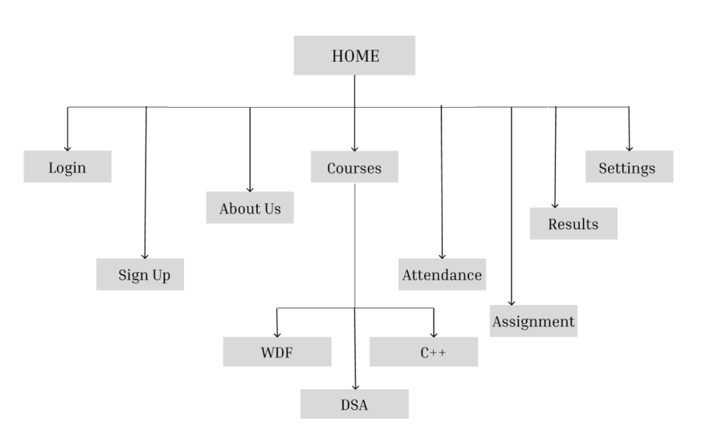

Description: This figure shows the sitemap and navigation structure of the StudentHub Portal. It illustrates the hierarchy of web pages and the links between the Home page, main sections, and individual course pages such as WDF, C++, and DSA.
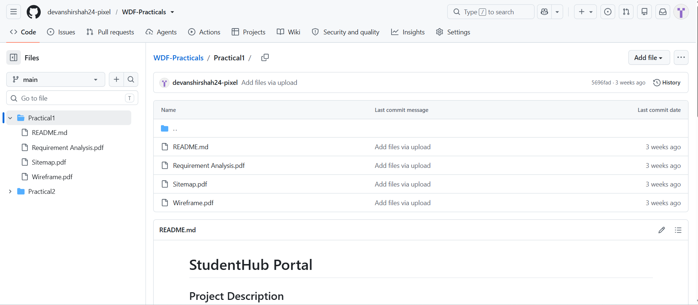
Description: This figure shows the GitHub repository of the StudentHub Portal project. It contains the work completed for Practical 1, including the Requirement Analysis, Sitemap, Wireframe, and README.md files. The repository is used to store and manage the project files and maintain the work completed during the practical.

GitHub Repository Link:

https://github.com/devanshirshah24-pixel/WDF-Practicals/tree/main/Practical1

Challenges Faced:
• Creating proper navigation: Initially, connecting multiple HTML pages was difficult because incorrect file paths caused broken links. This was solved by checking the folder structure and using the correct relative paths in the <a href=""> tags.
• Planning the sitemap: It was difficult to decide how many pages were required and how they should be connected. This was solved by first identifying the main StudentHub modules and then arranging them hierarchically.
• GitHub setup: Initially, understanding Git commands such as add, commit, and push was challenging. This was solved by following the Git workflow and maintaining meaningful commit messages after each major task.
• Maintaining project structure: Managing HTML, CSS, JavaScript, and image files became difficult when everything was kept in one folder. Separate folders were created for CSS, JavaScript, and images to make the project organized.

Learning Outcomes:
• The meaning and different parts of a URL.
• How an HTML file is requested and processed by a web browser.
• How multiple HTML pages can be connected using hyperlinks.
• How to plan a website using a sitemap.
• How to create a basic low-fidelity wireframe.
• How to identify user roles and modules for a web project.
• How to organize files and folders in a web project.
• How to create and initialize a GitHub repository.
• How to use basic Git commands such as git add, git commit, and git push

Faculty Remarks: (Keep this blank for faculty)

